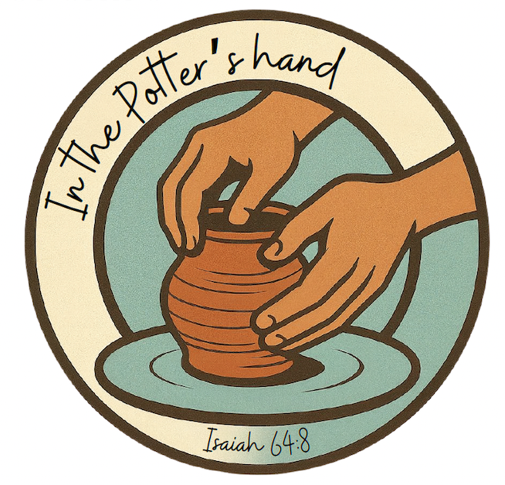

Our theme verse for this 2026 National Gathering is
Isaiah 64:8 (RSV)
O Lord, You are our Father;
we are the clay, and You are our Potter;
we are all the work of Your hand.

Our theme song for this event is “Change My Heart, Oh God.”

